**Quick guidelines for ABIapp**

**General information of ABIapp**

The ABIapp (Applying taxonomic Boundaries for species Identification) application was developed for users who require assistance in species delimitation of parasitic helminths. The application was developed from the GenBank sequence database of all current parasitic helminths to determine the cut-off genetic distance values ​​at each taxonomic level (from species to order) using a machine learning algorithm (Chan et al., 2021). The ABIapp is easy to use, as users just have to input the genetic distance value of the molecular genetic marker often used to classify parasitic helminths (18S rRNA, 28S rRNA, ITS1, ITS2, *COI*, *COII*, *cytB*, *ND1*, 12S rRNA, and 16S rRNA). The ABIapp will display the specimen’s taxonomic status based on the input genetic distance. Moreover, the ABIapp can recommend alternative genetic markers in cases where the initial molecular genetic marker used is not suitable.

**The problem of helminth identification**

Helminth species identification through morphology can be hindered with factors like ambiguous characters and phenotypic plasticity, making species identification challenging. In some instances, helminths can only be morphologically classified up to the genus level unless data from molecular genetic markers can indicate the degree of genetic variations. However, species boundaries remain a challenge because genetic variation can vary from the type of molecular genetic marker used and differences in the degree of genetic variation between incompatible groups of the parasitic helminths, for example, between nematodes and trematodes.

**ABIapp benefits**

The ABIapp application is straightforward as it uses genetic distance for species delimitation and determines the taxonomic status of parasitic helminths. Species identification of trematodes, cestodes, and nematodes is often difficult based on their morphological characters, which may be ambiguous or incomplete specimens. The ABIapp can aid in classifying a specimen to a probable taxonomic level and whether the specimens belong to the same or different species. The user does not need to distinguish species based on morphology but just know which group or family the specimen belongs to. The ABIapp applies to all parasitic helminths in humans and animals, as the data used covers nematodes, trematodes, and cestodes up to the Order level.

Before you start:

Species or groups of helminths should be identified by morphological characters at the beginning. However, if the specimens are unidentifiable due to incomplete morphological characters, biological or clinical data can be used to determine probable helminth groups. The user must have the genetic sequence information obtained from one of ten molecular genetic markers to use the application. Next, the genetic sequence information obtained can be compared with the GenBank Database to search for species that are genetically similar through BLAST. Then, genetic distances can be calculated by selecting approximately 3-5 similar species for sequence analysis. The pairwise distances can be analyzed using a user-friendly phylogenetics program, such as MEGA.

Using ABIapp:

The ABIapp requires the following information: genetic distance value, helminth group of interest, and genetic marker used.

1. Input genetic distance value (0 to 1)
2. Select helminth group of interest:

Cestode, Trematode, Nematode (Trichocephalida),

Nematode (Ascaridida and Spirurida), Nematode (Strongylida)

1. Select genetic marker used to obtain genetic distance:
2. Select ‘Go!’ to run the application

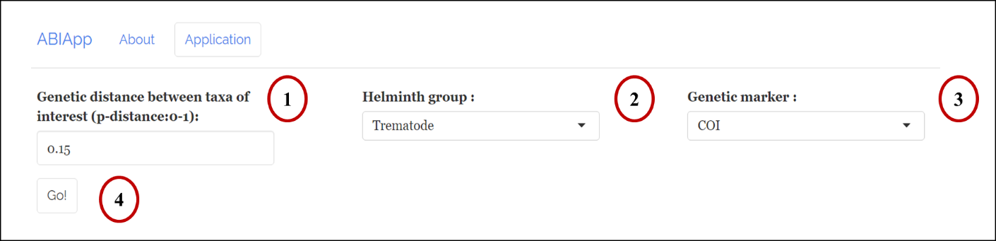

Interpreting the results:

ABIapp displays the results through:

* graphical visualization, where the queried genetic distance value is indicated by a grey dashed line against the range of genetic distances for each taxonomic hierarchy level.

* interpretation of the result obtained in a text box, where examples include:

1. ‘They are different species/genera/family/order’ – indicating two different species/genera/family/order as the queried genetic distance falls within the minimum and maximum values at the respective taxonomic level.

2. ‘Out of bounds’ – indicating the possibility of cryptic species, subspecies, or population level as the queried genetic distance falls below the minimum value at the species level.

3. ‘Suggest to use another genetic marker’ – indicating that another genetic marker might be more suitable for species delimitation of the selected taxa of interest as the queried genetic distance falls in-between two taxonomic levels.

They are different species

* Table, where the mean, minimum, maximum, and standard deviation of the estimated genetic distances using K-means with the specified genetic marker and helminth group of interest is displayed.

Using the above example, the queried genetic distance for two trematode taxa using the *COI* gene is **0.15**. Based on the ABIapp, the genetic distance of **0.15** falls within the interspecies level, indicating that the two trematode taxa are different species. The table also shows that the mean genetic distance at the species level is 0.146, and the genetic distance ranges from 0.087 to 0.177.

In another example, if the queried genetic distance for two trematode taxa using the *COI* gene is **0.18**, the genetic distance falls between species and genus level.Based on the ABIapp, the COI gene result is inconclusive for the queried genetic distance. Another genetic marker is recommended for molecular analysis in this scenario to better interpret results. ABIapp will suggest potential genetic markers to users in red boxes. In this instance, the mitochondrial 16S rRNA gene is recommended as another genetic marker to interpret results better. Although the mitochondrial rRNA genes (12S and 16S) are not highly popular for helminths, their suitability and robustness for helminth molecular identification were recently revealed (Chan et al. 2020, 2021, 2022).

Suggest to use mt 16S

The application can be accessed at <https://slphyx.shinyapps.io/ABI>. More information and assumptions for the ABIapp can be found there, along with suggested helminth PCR primer sets that are useful to obtain DNA sequences.

**Reference:**

Chan AHE, Chaisiri K, Morand S, Saralamba N, Thaenkham U. (2020) Evaluation and utility of mitochondrial ribosomal genes for molecular systematics of parasitic nematodes. Parasites & Vectors. 13(364)

Chan AHE, Chaisiri K, Saralamba S, Morand S, Thaenkham U. (2021) Assessing the suitability of mitochondrial and nuclear DNA genetic markers for molecular systematics and species identification of helminths. Parasites & Vectors. 14(233)

Chan AHE, Saralamba N, Saralamba S, Ruangsittichai J, Thaenkham U. (2022) The potential use of mitochondrial ribosoma genes (12S and 16S) in DNA barcoding and phylogenetic analysis of trematodes. BMC Genomics.